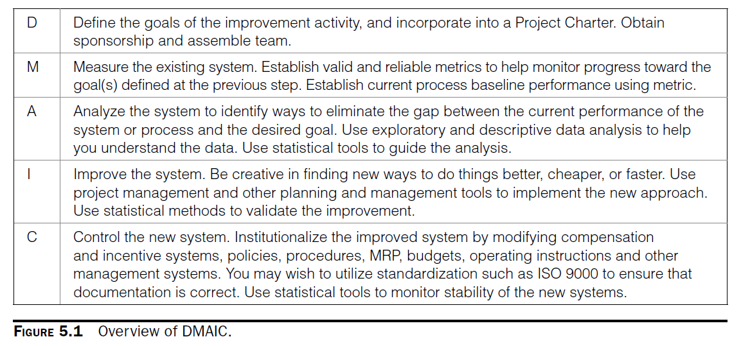

## Objectives

|  |  |
| --- | --- |
|  |  |

## Steps to follow

Planning

1. **Create a Project Charter Statement**
2. **Feasibility Analysis (Problem Framing)**
3. Project Evaluation (skip)
4. Determine metrics to measure progress to project goals (skip)
   1. Total Budget for This Project
   2. One or more metrics for each project deliverable
5. **Refining the Dollar Opportunity Estimates**
6. Creating schedule and project cost (skip)

Define

1. Cross-Functional Process Map
2. Describe the undesirable effects (UDE)
3. Prioritize the most important using 7M, pareto, cause-and-effect or EDA
4. Define related process metrics based on quality (CTQ), cost (CTC) or schedule (CTS).

## Project charter example

The project charter includes the project justification, the major deliverables, and the project objectives.

## Cost-Benefit Opportunity

## Cross-Functional Process Map

## SIPOC

## Useful tools

